**WSTIMS FOR WINDOWS USERS NEWSLETTER**

July 14, 2016 ISSUE 06 VOL. 16

Editor: Jeff Clark jclarksr94@gmail.com Programmer: Dave Allen

This newsletter is for you, the user, to inform you of problems that have been sent in from scorers across the nation and the solutions for those problems. We will be sending this out from time to time to keep you informed and assist you in usage of the program. If you have a problem or issue that needs to be addressed send an email to the editor and we will get your problem addressed immediately and keep all of the users informed of the problems/solutions involved.

**Update 3.0.0.8 is Available for Downloading**

The updated version 3.0.0.8 is now available for download. This update has fixed several errors reported to us.

When resending Trick videos, the data did not go with the upload and this has been fixed.

Running Orders were not printing the Event groups on the running Orders and this has been fixed.

**Slalom Summary And Scorebook Not Posting Correct Placements For Tie Breakers Using The RO section**

When using “First” as the placement option in the Master Scorebook settings, which is typically only used in Multi Round State and Regional tournaments, the runoff score was not being applied properly. This ~~has~~ is the procedure to correct the problem.

If you found this problem in your Multi round State tournament, do the following tasks:

1. Open up your tournament from the “Tournament List”.
2. Click the Tournament button and click the Tournament Package Build.
3. Click the Performance Data File to run the report.
4. Click on the Scorebook (sbk) to run the scorebook
5. Click on the Scorebook (web) (Championship) to run the html scorebook.
6. Click on Tournament Package to finalize all of your changes.
7. Check your Slalom Summary to make sure the placements are correct and also look at your 16XYYYCS scorebook to verify that it was corrected.
8. If all is good, send the revised zip file to your Region Seeding representative

**State and Regional Tournament Setup**

This year I neglected to send out the instructions for setting up and scoring a State and Regional tournament. Some of the Chief scorers for the State tournament held this past weekend did not follow the standard and required protocol for their tournaments which caused problems with the seeding (wsp) file for placements and improper scorebooks. The updated procedures are in the next article and are to be followed exactly as outlined. Any personal variances or changes to the protocol specified below, will cause you to have to fix the errors and resubmit your tournament files. This causes all kind of problems for the Regionals that follows for participants trying to qualify and then also for the Nationals.

Please review the updated procedures below and do not vary from the instructions as outlined.

# State and Regional Tournament Setup and Scorebook Options Review

We are about to enter the time of the season for the State Championships and Regional tournaments. We need to review the standard procedures that we have used for many years and cover the setup issues so that the Scorebook and the seeding files are produced properly using the WSTIMS for Windows program.

There are standard procedures to be used for all State, Regional Championships. WSTIMS has the procedures built in and the following procedures are to be used as stated. **DO NOT USE ANY PERSONAL VARIATIONS TO THE PROCEDURES OR YOUR REPORTS AND SCOREBOOKS WILL NOT TURN OUT CORRECTLY.**

First let’s review the standard operating procedures for the State championships. Each state has a set of qualifying procedures to enter the tournament and the primary requirement is to be a resident of the state in order to enter the tournament. In addition to these participants, the states have been allowing out of state skiers to enter the tournament and ski for scores on the Ranking List only. This allows the program to award the qualified in state skiers placements for awards and to be recognized as State Champions in their events.

The way that we separate these two groups of skiers is very simple and has been in place for many years.

1. In the tournament you have both individual skiers and those skiing for Overall awards.
2. For all of the qualified state residents, use the standard **age division codes** for all of the events that the skier enters. This will make all of the Overall scores and age division events calculate the scores properly. This also **sends the placements to the Performance Data File** (wsp) when you build the Tournament Package. This is needed for qualifications for other tournaments. **DO NOT USE ADMINISTRATIVE GROUPS FOR ANY OF THESE QUALIFIED PARTICIPANTS, ONLY AGE DIVISION.**
3. For the “out of state” skiers you should isolate them into a separate group so the program will isolate their scores from the rest of the qualified participants and **will not put their placements in the seeding list, only their performances for the Ranking List.** We have designated in the program the appropriate protocols for the Ranking List and have this tied to the standard code of **“RL”** for these skiers and you must use this code for each event entered by the out of state or out of region skier so that your scorebook will work properly and only the scores will be posted to the Performance Data File, not placements.
4. To make your Scorebook and the related Seeding file handle this properly during and at the end of the tournament you will need to go to the Administrative tab > Tournament List > Set Report Properties.

There are three sections in the list of reporting properties that you need to edit.

Master Scorebook Reporting Properties > the first option is Scores to Use > select First, in the second option box Points Calculation Method > select NOPS, in the third option Placement Option > select score, and in the fourth option Placement Grouping > select Div/Group as the settings for your Scorebook.

In the Master Overall Reporting Properties section the settings will be Scores to Use > select Round, Points Calculation Method > select NOPS, Placement Option > select Points, and in the fourth option Placement Grouping > select Div/Group as the settings for your Scorebook.

1. A byproduct of this of course, is that the Running Order option in the program will isolate these skiers in this special group and be easy for you to use when creating your running orders for the tournament. Most of the state tournaments are seeded and these skiers in the RL group always ski first, with several asterisks in front of their name to identify them on the running order.
2. You would then score your tournament as you usually do and the program will take care of storing the data.
3. Some of the tournaments are hosting two rounds of competition. The standard in this situation is for the Round 1 scores to reflect the State/Regional Championships and the Round 2 scores are to be used for the Ranking List only.
4. When you run your reports in the Tournament Package Build tab, and the “Scorebook (Web)” report is about to be produced, a dropdown panel will appear with the three types of scorebooks available to be produced and you should choose the “Championship/Index” format for this Scorebook.

When you are the Chief Scorer for your Regional tournament the same procedures listed above must be used for the tournament.

You should send the tournament ZIP file to your Regional Seeding Representative no later than Monday after the tournament, so that the scores will be available for the Regional and National tournament qualifications for the skiers.

July 13, 2016

# AWSA State, Regionals, And Nationals Team Setup and Assignment

* Enter the 2 to 4 character team code (the state code is your choice in State and Regional Championships, use standard code for regions at Nationals) in column D of the registration template
* Save template normally as a tab delimited txt file
* Setup tournament normally
* Administration > Import > Standard Registration Template  
  Import the registration template text file as is normally done.  
  This will assign any skier with a team code to that team for all events the skier is marked to participate in.
* Open Team Management  
  Tournament > Team Management  
  Teams are sorted by the name  
  The skiers in each event window are sorted by team code, then division, and then rank  
  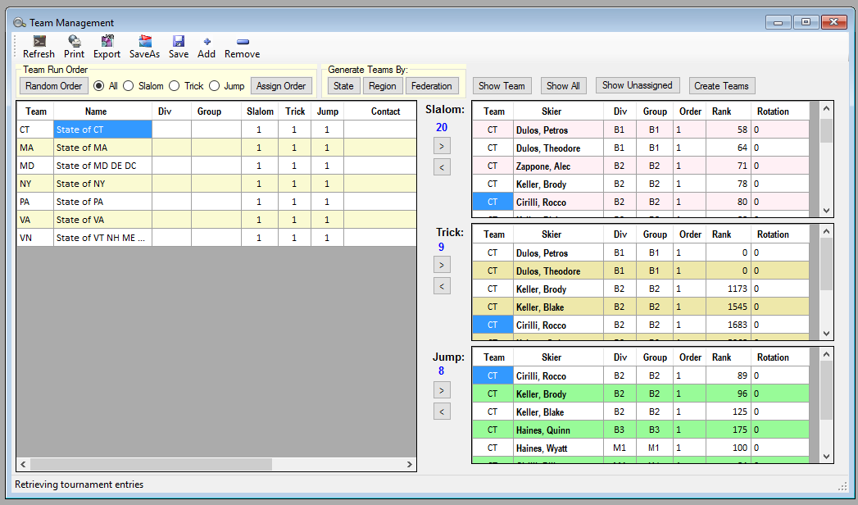
* Update team names as desired – “Name” column
* Click on the Show Team button  
  This will show just the skiers in each event that are assigned to the team selected on the left – “Team” column
* For each event remove the skiers that should not be assigned to the particular team in that particular event  
  To remove a skier click on the skier name, then click on the arrow pointing left associated with the event – “Center” column between panels
* Click on the Show All button
* To add a skier to a team for a particular event, scroll to the top of the list of skiers for the particular event. Skiers not assigned to a team will sort at the top and will have no value in the team column.
* Click on the skier name you want to add to a team  
  Click on the team name on the left for the desired team assignment  
  Click on the arrow button pointing to the right for the desired event - “Center” column between panels
* Repeat this process for all teams and skiers for team assignment

# Team Score Reporting

* Open Team Summary  
  Tournament > Team Summary  
    
  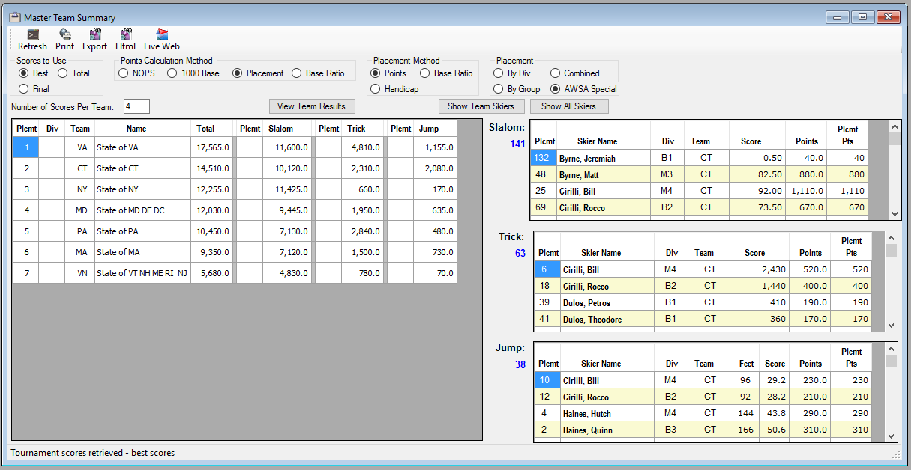
* Select Best for Scores to Use
* Select Placement for Points Calculation Method
* Select Points for Placement Method
* Select AWSA Special for the Placement
* Enter 4 for Number of skiers per team
* Click Refresh  
  Note depending on your computer’s memory and processor speed this make take several minutes to complete
* When the report is completed, click on the View Team Results button  
    
  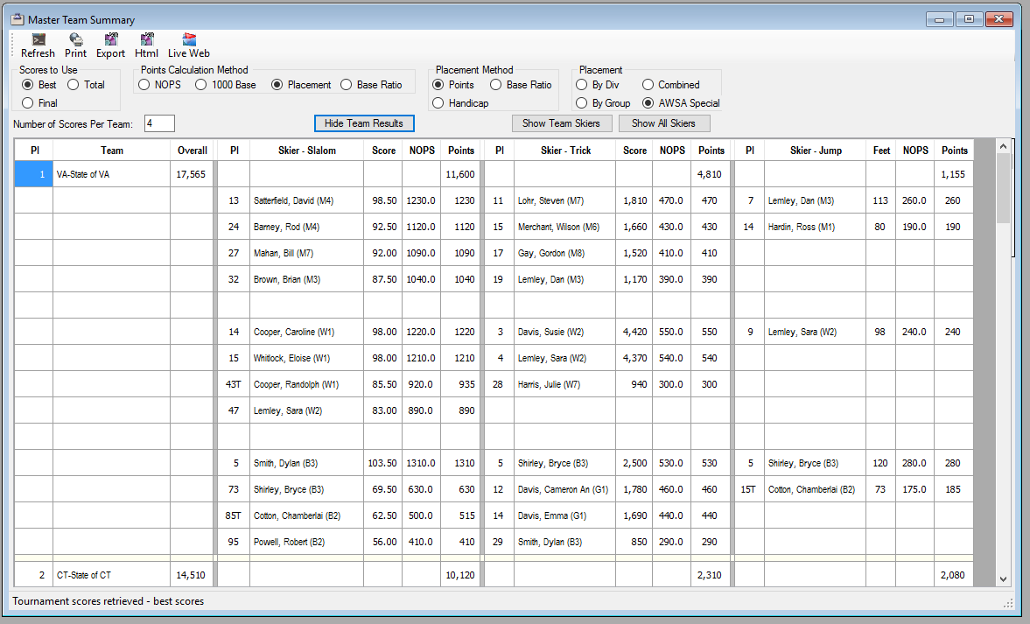
* You can print these results or Export to a text file or to an HTML file
* If you want to send these results to the Live Web Scoreboard  
  Click on the Live Web icon  
  Activate the Live Web location  
  Click on the Live Web icon again  
  Click on Resend Visible Skiers  
  This will make the team results available on the Web Scoreboard
* On the Web Scoreboard find the tournament and then select the Team button  
    
  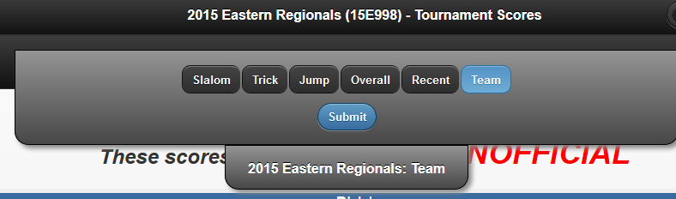
* 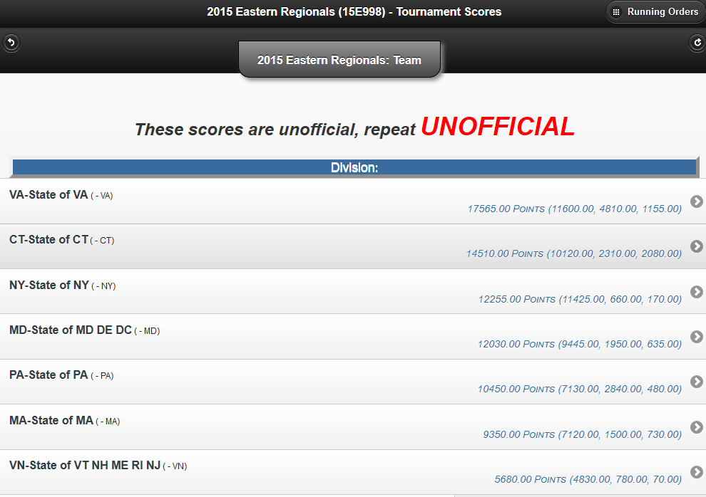
* Click on any team name to see the skier details for this team results